 | Northampton International Academy  PSHE Curriculum Overview (Secondary) 2026-27 | 

Why Teach Personal, social, health and economic education?

Our PSHE curriculum is wide ranging and made makes a strong contribution to our pupils’ personal development and helps to prepare them to become responsible, respectful and active citizens who can play their part and become actively involved in public life as adults. The curriculum links closely with the RSE and dedicated careers curriculums, tutor programme which includes Votes for Schools, the programme of assemblies, external visitors, parent and carer workshops and other events. It is also developed through all other curriculum subjects. In our curriculum overview we have identified the important knowledge we want our pupils to learn. Through our PSHE curriculum, we:
- enable pupils to develop the knowledge, skills and attributes they need to manage many of the critical opportunities, challenges and responsibilities they will face at different stages of their lives and as they grow up and enter into adulthood.
- support pupils’ personal development and help them to develop self-esteem, resilience, empathy and to stay safe and healthy.
- equip pupils with a good understanding of different risks they may face and the knowledge and skills necessary to make safe and informed decisions.
- give pupils an age-appropriate understanding of the fundamental British values: democracy, the rule of law, individual liberty and mutual respect for and tolerance of others, including those with different faiths and beliefs and those without faith.
- give pupils an age-appropriate understanding of the Equalities Act including in relation to the protected characteristics and what this means in pupils’ lives.
- support pupils’ social, moral spiritual and culture development.
Substantive Big Ideas Our PSHE curriculum has 7 key themes pupils learn about.
These strands, covered in each year are:

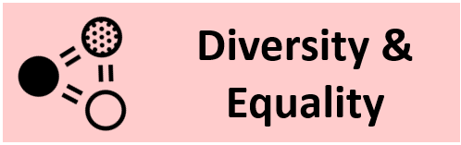

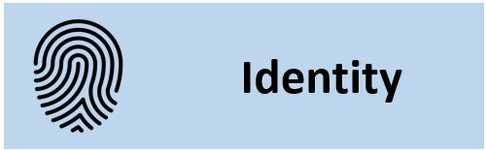
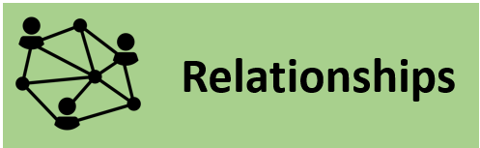
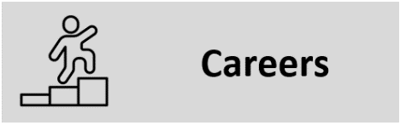

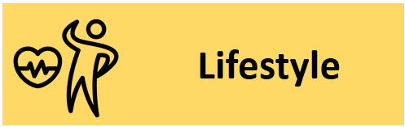
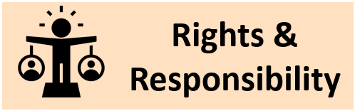

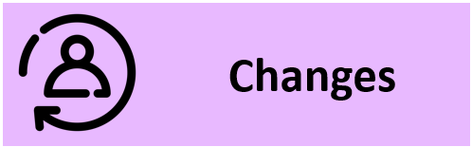

The DNA of NIA
The DNA of NIA character drivers are:

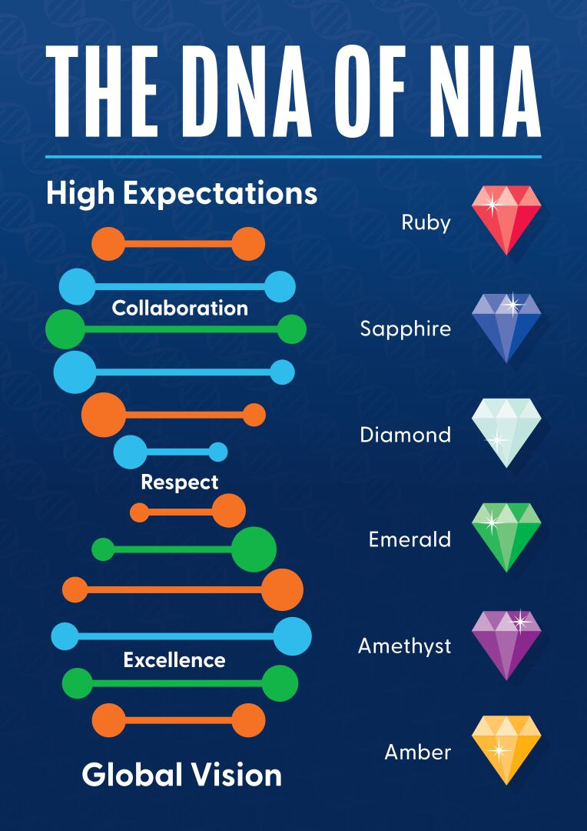

Staff at NIA reinforce these constantly: through the PSHE curriculum as well as the wider curriculum and school life.

Jigsaw – PSHE Lessons
Our PSHE curriculum draws upon the ‘Jigsaw’ resources. Through this, as well as other resources such as ‘Votes for Schools’, assemblies, tutor time, we help to prepare pupils for life, helping them really know and value who they are and understand how they relate to other people in this ever-changing world.
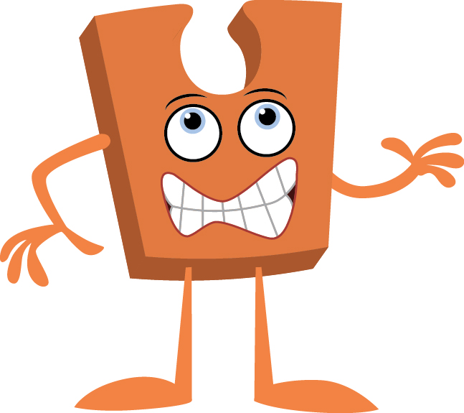 | Being Me in My World
 | 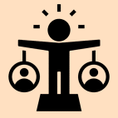
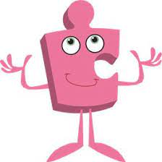 | Celebrating Differences
 | 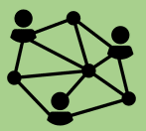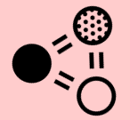
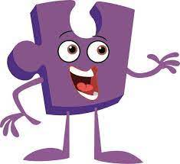 | Dreams and Goals
 | 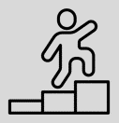
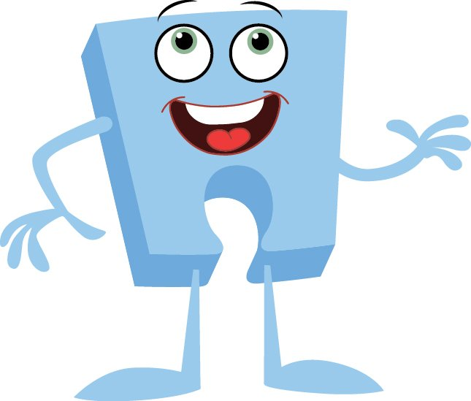 | Healthy Me
 | 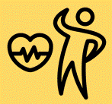
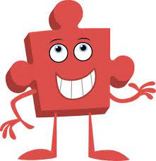 | Relationships
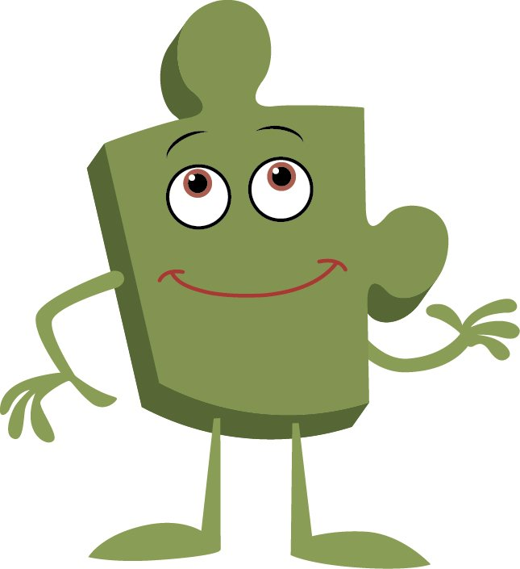 | Changing Me

Bounce Forward
Bounce Forward, in partnership with the Harry Kane Foundation create lessons focused on resilience and mental wellbeing. We deliver Bounce Forward resources in Year 7 and Year 8 PSHE lessons as well as in assemblies across the Primary, Secondary and Sixth Form phases.
Year 7 lessons focus on Resilience Skills, Media Navigator and Intentional Stillness.
Year 8 lessons focus on Resilience, School to Life and Media Influences
EC Publishing and Cre8tive Resources
KS5 PSHE lessons are created using a combination of the above resource providers in order to create a bespoke curriculum appropriate for our cohorts’ needs as well as responding to emerging local and national issues.

Northampton International Academy
PSHE Curriculum Map – Topics by Term (Jigsaw Curriculum)

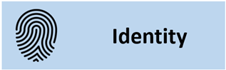 | 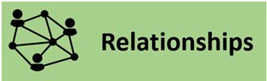 |  | 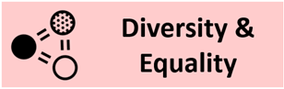 | 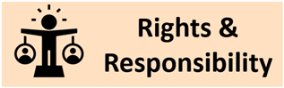 | 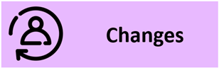 | 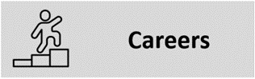

 |  |  |  | Year 7 | Year 8 | Year 9 | Year 10 | Year 11 | Year 12 | Year 13
Autumn 1 |  |  |  | Unique me, differences & conflict, my influences, peer pressure, online safety, sexting, consequences, online legislation | Self-identity, family and identity, stereotypes, personal beliefs and judgements, managing expectations, first impressions, respect for the beliefs of others. Active listening | Perceptions about intimate relationships, consent, sexual exploitation, peer approval, grooming, radicalization, county lines, risky experimentation, positive and negative self-identity, abuse and coercion, coercive control | Human rights, societal freedom, understanding safety in UK and beyond, ending relationships safely, stages of grief, loss and bereavement, social media and culture, use of online data, threats to online safety, online identity, assessing and managing risk | BEING ME IN MY WORLD  Equality in relation to disability including hidden, consequences of not adhering to Equality Act, employers’ responsibilities, benefits of multicultural societies, impact of unfair treatment on mental health, misuse of power, campaigning for equality | Drugs, Risk and Crime Education | Sexual Health and Relationships Education
Being me in My World
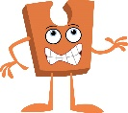
Autumn 2 |  |  |  | Bullying, prejudice  & discrimination, Equality Act, bystanders, stereotyping, challenging negative behaviour and attitudes | Positive change made by others, how positive behaviour affects feelings of wellbeing, social injustice, inequality,  community cohesion and support, multiculturalism, race and religion, prejudice, LGBT+ bullying | Protected characteristics, Equality Act, phobic and racist language, legal consequences of bullying and hate crime, sexism, ageism, positive and negative language, banter, bullying in the workplace, direct and indirect discrimination, harassment, victimisation. Prejudice, discrimination and stereotyping | Equality including in the workplace, in society, in relationships. Equality and vulnerable groups. Power and control | Mock exams/study leave | Careers | Careers/Life Skills
Celebrating Differences
Spring 1 |  |  |  | Celebrating success, identifying goals, employment, learning from mistakes, overcoming challenges, planning skills, safe & unsafe choices, substances, gangs, exploitation, emergency first aid | Long-term  goals, skills, qualifications, careers, money and happiness, ethics and mental wellbeing, budgeting, variation in income, positive and negative impact of money, online legal responsibilities, gambling issues | Personal strengths, health goals, SMART planning, links between body image and mental health, nonfinancial dreams and goals, mental health and ill health, media manipulation, self-harm, anxiety disorders, eating disorders, depression. | Impact of physical health in reaching goals, relationships and reaching goals, work/life balance, connections and impact on mental health, benefits of helping others, online profile and impact on future goals | DREAMS AND GOALS  Managing overwhelm and anxiety, money and debt, dream jobs and skill set, My future relationships, what to do when things go wrong. | Personal Finance | Drugs, Risk and Crime Education
Dreams and Goals
Spring 2 |  |  |  | Stress and anxiety, managing mental health, physical activity and mental health, effects of substances, nutrition, sleep, vaccination and immunisation, importance of information on making health choices | Long-term physical health, responsibility for own health, dental health, stress triggers, substances and mood, legislation associated with substances, exploitation and substances, medicine, vaccinations, immunisation Blood donation | Misperceptions about young peoples’ health choices, physical and psychological effects of alcohol, alcohol and the law, alcohol dependency, drug classification, supply and possession legislation, emergency  situations,  first aid, CPR, substances and safety, sources of advice and | Improving health, sexual health, blood-borne infections, self-examination, diet and long-term health, misuse of prescription drugs, common mental health disorders, positive impact of volunteering, common threats to health including chronic disease, epidemics, misuse  of antibiotics Organ donation  Stem cells | HEALTHY ME  Managing anxiety and stress, exam pressure, concentration strategies, work- life balance, sexual health, hygiene, self-examination, STIs, sexual pressure, fertility, contraception, pregnancy facts and myths, identifying a range of health risks and strategies for staying safe | Diversity, Equality and Inclusion | Emotional Wellbeing
Healthy Me
Summer 1 |  |  |  | Characteristics of healthy relationships, healthy romantic relationships, consent, relationships and change, emotions within friendships, being discerning, assertiveness, sexting | Positive relationship with self, social media and relationship with self, negative self-talk, managing a range of relationships, personal space, online etiquette, online privacy and personal safety, coercion, unhealthy balance of power in relationships, sources of support | Power and control in intimate relationships, risk in intimate relationships, importance of sexual consent, assertiveness skills, sex and the law, pornography and stereotypes, contraception choices, family planning, STIs, support and advice services | Sustaining long-term relationships, relationship choices, ending relationships safely,  consequences of relationships ending e.g. bullying, revenge porn, grief-cycle. Divorce and separation, impact of family breakup on children, understanding love, fake news and rumourmongering, abuse in teenage relationships. Legislation, support and advice | RELATIONSHIPS  Stages of intimate relationships, positive and negative connotations of sex, protecting sexual and reproductive health, safely ending relationships, spectrum of gender and sexuality, LGBT+ rights and protection under the Equality Act, “coming out” challenges, LGBT+ media stereotypes, power, control and sexual experimentation, forced marriage, honour-based violence, FGM and other abuses, hate crime, sources of | Wellbeing | Exams/Study leave
Relationships
Summer 2 |  |  |  | Puberty changes, FGM, breast flattening/ironing, responsibilities of parenthood, types of committed relationships, happiness and intimate relationships, media and self-esteem, self-image, brain changes in puberty, sources of help and support | Types of close intimate relationships, physical attraction, legal status of relationships, behaviours in healthy and unhealthy romantic relationships, pornography, sexuality, alcohol and risky behaviour | Mental health stigma, triggers, support strategies, managing emotional changes, resilience and how to improve it, reflection on importance of sleep in relation to mental health, reflection on body and brain changes, stereotypes | Impact of societal change on young people, role of media on societal change, reflection on change so far and how to manage it successfully, decision making, sexual identity gender, spectrum of sexuality, stereotypes in romantic relationships, sexual identity and risk, family change, sources of support. | Exams/study leave | Mock exams/UCAS | Exams/Study leave
Changing Me
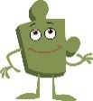

Northampton International Academy
KS5 PSHE Curriculum Map – Topics by Term

 |  |  |  | Year 12 | Year 13
Autumn 1 |  |  |  | Drugs, Risk and Crime Education.  Including Class A Drugs, Class B Drugs, Class C and Prescription Drugs, Festival & Parties, Alcohol, Substances and Knife Crime. | Drugs, Risk and Crime Education.  Including Festival Drugs, War on Drugs, Knife Crime, Hate Crime and Cultural Appropriation.
Drugs, Risk and Crime Education (12)
Sexual Health Education (13)
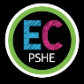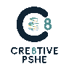
Autumn 2 |  |  |  | Careers.  Including University, Apprenticeships, Types of Employment, Career Leadership Skills, Employability and Problem Solving. | Careers and Life Skills.  Including Renting or Buying Property and Cars, Work Ethic and Motivation, Careers Personal Branding, Researching Different Jobs and Critical Thinking and Fake News.
Careers (12)
Careers and Life Skills (13)
Spring 1 |  |  |  | Diversity, Equality and Inclusion.  Including Feminism, LGBTQ+ Inclusion, Free Speech and Hate Speech, Toxic and Positive Masculinity, Tolerating Intolerance and Social Justice. | Relationships and Sexual Health Education.  Including Contraception, Controlling Relationships, Pornography and Sex and Media, STIs and Sexual Health, Miscarriage and Unplanned Pregnancy and Sexual Readiness and Encounters.
Personal Finance (12)
Personal Finance/Life Skills (13)
Spring 2 |  |  |  | Emotional Wellbeing.  Including Looking after your Health and Wellbeing, Stress Management, Physical Health, Nature Nurture Mental Health, Body Image and Dealing with Anger. | Emotional Wellbeing.  Including Looking after your Health and Wellbeing, Stress Management, Physical Health, Nature Nurture Mental Health, Body Image and Dealing with Anger.
Diversity, Equality and Inclusion (12)
Drugs, Risk and Crime Education (13)
Summer 1 |  |  |  | Personal Finance.  Including What is Debt, Payday Loans, Banks and Money, Insurance Types, Taxes and the UK and Income and Benefits. | Revision
Wellbeing (12) |  |  |  |  | Revision
Summer 2 |  |  |  | Work Experience/Mock Exams/UCAS | Exams/Study Leave
PSHE curriculum suspended in summer term 2 for Year 12 and summer term 1 and 2 due to exam leave, mocks and work experience. |  |  |  | Work Experience/Mock Exams/UCAS | Exams/Study Leave

Northampton International Academy
PSHE Curriculum Map – Topics by Term (Bounce Forward Curriculum)

 |  |  |  | Year 7 | Year 8 | Year 9
Autumn 1 |  |  |  | Resilience Skills  A unit focused on building emotional resilience exploring emotional responses to problematic situations. Exploring emotion gremlins and unhelpful thinking patterns as well as calming techniques to build emotional resilience and promote wellness. | Resilience Revisited  A unit focused on building a deeper understanding of emotional resilience exploring emotional responses to problematic situations. Exploring emotion gremlins and unhelpful thinking patterns as well as calming techniques to build emotional resilience and promote wellness. Exploration of the ABC thinking model. Activating event – belief – consequence. | Resilient Relationships  A unit focused on building resilience in relationships, recognising positive and negative behaviours in relationships. Identifying healthy boundaries in relationships. Focusing on positive human connections and links to planning for the future.
Resilience Skills (7 and 8)

Autumn 2 |  |  |  | Resilience Skills  A unit focused on building emotional resilience exploring emotional responses to problematic situations. Exploring emotion gremlins and unhelpful thinking patterns as well as calming techniques to build emotional resilience and promote wellness. | Resilience Revisited  A unit focused on building a deeper understanding of emotional resilience exploring emotional responses to problematic situations. Exploring emotion gremlins and unhelpful thinking patterns as well as calming techniques to build emotional resilience and promote wellness. Exploration of the ABC thinking model. Activating event – belief – consequence. | Resilient Relationships  A unit focused on building resilience in relationships, recognising positive and negative behaviours in relationships. Identifying healthy boundaries in relationships. Focusing on positive human connections and links to planning for the future.
Resilience Skills (7 and 8)

Spring 1 |  |  |  | Media Navigator  A unit focused on understanding the risks, challenges and benefits of being online. Safer social media use alongside references to fake news, misinformation and disinformation. | Media Influences  A unit focused on developing students understanding the risks, challenges and benefits of being online. Safer social media use alongside references to fake news, misinformation and disinformation. References to positive online role models vs negative influence. | Mental Health Investigated  A unit focused on defining mental health and the signs of mental illness. Exploring and understanding triggers, protective factors and promoting wellbeing. Identifying and supporting others with poor mental health and reducing mental health stigma.
Media Navigator (7)
Media Influences (8)
Spring 2 |  |  |  | Media Navigator  A unit focused on understanding the risks, challenges and benefits of being online. Safer social media use alongside references to fake news, misinformation and disinformation. | Media Influences  A unit focused on developing students understanding the risks, challenges and benefits of being online. Safer social media use alongside references to fake news, misinformation and disinformation. References to positive online role models vs negative influence. | Mental Health Investigated  A unit focused on defining mental health and the signs of mental illness. Exploring and understanding triggers, protective factors and promoting wellbeing. Identifying and supporting others with poor mental health and reducing mental health stigma
Media Navigator (7)
Media Influences (8)
Summer 1 |  |  |  | Intentional Stillness  A unit focused on physical wellness specifically exploring calmness and stillness. Mindfulness practice explored. | School to Life  A unit focused on bringing skills learnt in school into use for everyday life situations, including conflict resolution, exam stress management and positive wellbeing and mindfulness. | Physical Resilience  A unit focused on understanding the benefits of physical wellness and resilience. Exploring links between physical wellness and mental wellbeing.
Intentional Stillness (7)
School to Life (8)
Summer 2 |  |  |  | Intentional Stillness  A unit focused on physical wellness specifically exploring calmness and stillness. Mindfulness practice explored. | School to Life  A unit focused on bringing skills learnt in school into use for everyday life situations, including conflict resolution, exam stress management and positive wellbeing and mindfulness | Physical Resilience  A unit focused on understanding the benefits of physical wellness and resilience. Exploring links between physical wellness and mental wellbeing.
Physical Resilience (7 & 8)

 | Northampton International Academy  Secondary PSHE Curriculum Overview | 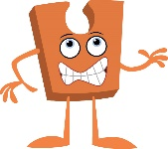 | Being Me in My World | 
Key: PSHE Learning Intentions / Social and Emotional Skills Learning Intentions.
 | Year 7 Autumn 1 | Year 8 Autumn 1 | Year 9 Autumn 1 | Year 10 Autumn 1 | Year 11 Autumn 1
 | How do I fit into the world I live in? | Can I choose how I fit into the world? | To what extent does the world I live in affect my identity? | Is managing my online and offline world within my control? | Are we in the adult world at 16?
Being Me in My World – Jigsaw Autumn 1 | Who am I?  - I can explain what identity is, describing the different factors that shape who I am  - I can recognise what makes me unique  - I can recognise and respect the differences between myself and others, and show confidence in who I am  My Influences  - I can understand that identity is affected by a range of factors  - I can identify what influences my life  Peer Pressure and Belonging  - I understand how peer pressure operates within groups  - I can achieve an appropriate level of independence from others while maintaining positive relationships with them  My online identity  - I can recognise how I present myself online  - I can understand how to engage and respond responsibly with other users  - I understand how my online identity can affect what others think and feel about me  What are the consequences of what I say and do online?  - I understand what can influence my behaviour online  - I understand that what I say and do online can  have consequences for myself and others  Assessment  - I understand how to maintain positive on and offline relationships  - I understand what steps to take to stay responsible online  - I understand that what I say and do online can  have consequences for myself and others. | Identity and Influence  I can appreciate that identities are complex and can change over time  - I can appreciate the similarities, differences and diversity of people’s identities  - I understand that faith, families, communities and cultures influence identity and can start to identify the influences in my life  My ‘family’  - I can understand about collective and individual identities and cultural diversity  - I understand the influence family has on self- identity  - I can make sense of what has happened in my life and understand the influences from my own history and how they have shaped my self-identity, including those I’ve chosen to reject  Family factors.  - I understand how to identify influences and differences and use these positively in my relationships​  - I understand how to listen actively to other people​  - I can identify what is important for me and what I expect from myself, taking into account the beliefs and expectations of, for example, my family​  The power of first impressions.  - I understand that first impressions can lead to judgements that may be misinformed  - I understand that I can make accurate and inaccurate assumptions about my own and others’ identities  - I understand that I can make choices about the influences I accept as part of my personal identity  Faith and beliefs.  - I understand that that there is a range of beliefs within any community and I can recognise the beliefs I hold as important to me  - I can appreciate that people’s faiths and beliefs can affect their personal identity  - I can see the world from other people’s points of view and understand their beliefs  - I respect people’s right to hold their own views and beliefs  Assessment  - I can understand how people present themselves differently online and offline​  - I can recognise the positives and challenges of managing multiple identities  - I can reflect on my own online and offline identity and make choices authenticity | Being me in a group  - I can identify differences between myself and others in my social groups  - I can explain how differences can be a source of conflict or a reason to celebrate  - I can manage differences of opinion within my social groups to maintain positive and safe relationships  Expectations and perceptions of relationships  - I understand that different people have different expectations of intimate relationships  - I know how to access support if worried about a relationship issue  - I have an understanding of my own expectations of intimate relationships  Peer pressure and grooming  - I can explain peer approval and how it can cause problems  - I can describe what grooming is and give examples  - I have strategies to help me manage my peer group relationships  Risks  - I can suggest links between risky behaviour choices and the influence of social groups  - I know that I can accept or reject influences  - I know where to access help and advice if I am concerned about a risky situation in my life  Consent  - I can define consent and understand its legal and ethical importance in all relationships, including sexual relationships​  - I can identify the characteristics of consent and recognise when consent is present or absent in different situations​  - I can explore ways to communicate boundaries clearly and respect others' boundaries to build healthy relationships  Assessment  - I understand how the choices I make can be linked to my self-identity and self-esteem​  - I understand how self-esteem can affect my health and relationships​  - I feel confident about reassessing my own and others’ behaviour and choices | Liberty and safety in the world.  - I can list the freedoms I enjoy in society  - I can describe what personal freedom means to me  - I can describe my understanding of safety I can identify potential risks to my safety  - I understand that this can differ in other parts of the world  - I can compare my freedom and safety to that of teenagers in different parts of the world  How I feel when things end.  - I can describe the stages of grief  - I know where to appropriately get help and support with loss and bereavement issues  - I can discern which online sources or support in regards to loss/ grief are helpful or not.  - I understand the range of emotions associated with relationships ending  - I understand the behaviours that some people experience as a result of grief, this can be on or offline  - I can identify some of the ways some individuals manage grief and loss  How social media affects me, my identity and my culture.  - I recognise the positive and negative role of social media e.g. challenge culture vs environmental campaigns and awareness- building  - I understand the impact social media has on culture and identity  - I recognise how online data is used both positively and negatively  - I can compare social media usage across different societies  - I can reflect on how social media can impact on safety  Rated!  - I can identify potential threats to online safety  - I understand “netiquette” and legislation relating to online safety  - I can state decision-making process regarding what you post online  - I can critically assess own online identity  Personal data sharing – how risky is it?  - I can identify potential threats to safety in a range of situations on and offline  - I can describe actions to mitigate risk in a range of situations  - I know how to get help if personal safety is threatened  - I know some strategies for managing my feelings about how my world is changing  Assessment  - I understand how to stay safe in my online and offline relationships  - I understand the importance of thinking critically when using new technology  - I know some strategies for managing on and offline relationships, positively | Becoming an adult.  - I can state what ‘being an adult’ means to me  - I can give some examples of legislation that affects me at 16  - I can identify things I am looking forward to in adulthood, and things that concern me  - I know where to access help and information if I am worried or concerned about anything  Relationships and the law.  - I can give examples of legislation that relates to sex and relationships  - I know about the legal status of different relationships e.g. marriage, civil partnership, co-habitation  - I can explain why coercive control, sexual harassment and sexual violence in relationships is unacceptable, illegal and the consequences of this  - I can suggest ways to keep myself and others safe in regard to healthy and positive relationships  - I know how and where to access advice and support if I am concerned about a sex or relationship matter  County Lines.  - I can give examples of legislation around the possession and supply of drugs and illegal substances  - I can assess the impact of substance supply and misuse on the range of people involved in a scenario including coercive control  - I can suggest ways to keep myself and others safe  - I know how and where to access advice and support if I am concerned about the misuse of power or coercive control​  Gambling, Gaming and the Illusion  - I can identify different forms of gambling and gambling-like behaviours in games and apps  - I understand how digital systems, AI, algorithms, and targeted design can encourage risky behaviour  - I can recognise early signs of gambling harm and know where to find support  - I know how and where to access advice and support if I am concerned about gambling  Emergency situation.  - I know the steps to take in an emergency situation including assessment of the situation, making the area safe, giving emergency aid, accessing help  - I can apply this knowledge to a range of scenarios where emergency aid may be needed.  - I am aware of the feelings I might encounter when faced with an emergency situation and how those requiring my help might feel  Assessment  - I know some of the rights, responsibilities and laws that affect me  - I can give examples of legislation in reference to online use  - I know how and where to access advice and support if I am concerned about the misuse of technology

 | Northampton International Academy  Secondary PSHE Curriculum Overview |  | Celebrating Differences
Key: PSHE Learning Intentions / Social and Emotional Skills Learning Intentions.
 | Year 7 Autumn 2 | Year 8 Autumn 2 | Year 9 Autumn 2 | Year 10 Autumn 2 | Year 11
 | Do we need to feel ‘the same as’ to belong? | How different are we really? | Is being different a good thing? | Does difference result in equality?
Celebrating differences – Jigsaw Autumn 2 | Prejudice and discrimination.  - I can describe what prejudice and discrimination are  - I know what bystanders are and their impact on bullying  - I can explain some ways the Equality Act protects against prejudice and discrimination  - I know how I can challenge prejudice and discrimination assertively​  - I can be assertive when appropriate​  - ​I can identify what is important to me and what I expect from myself  True or false?  - I can challenge my own and others’ attitudes and values, and accept difference in others  - I can see the world from other people’s points of view and take account of their intentions, preferences and beliefs  - I know I have choices in how I allow others to influence me  Challenging stereotypes.  - I can understand the wide range of roles in society and the variety of individuals that operate within them  - I understand what stereotyping means and its potential impact  - I can define stereotyping and explain why it is Unhelpful  - I know that I am a unique individual, and I can think about myself and others on many different levels (e.g. physical characteristics, personality, attainments, attitudes, values, etc.)  Discrimination in school  - I can challenge prejudice and discrimination assertively  - I understand that positive and negative discrimination can take different forms and how it can affect people’s lives  - I know what the Equality Act is and can give some examples of protected characteristics  - I understand the impact of bullying, prejudice and discrimination on those involved and can think through how this can be alleviated  - I can take others’ thoughts and feelings into account in how I manage my relationships  - I know where and how to get help if I am on the receiving end of bullying, prejudice or discrimination (local and national sources of help | When prejudice becomes persecution  - I can explain key terms like persecution, intolerance, resistor, bystander, and perpetrator.  - I can explain how/why prejudice can become persecution  - I can recognise how propaganda influences people, past and present  - I can empathise with people affected by prejudice and consider how I can respond with kindness and courage  LGBT+ Phobia  - I can define what is and what is not bullying  - I can give examples of LGBT+ bullying  - I can describe the steps that can be taken to challenge LGBT+ bullying  - I understand the emotional impact of LGBT+ bullying on both victim and perpetrator  Social Injustice and Hate crime  - I can explain what social justice and social inequality mean  - I can identify what a hate crime is  - I can evaluate the benefits of living in a multicultural society  - I can reflect on my own values and how they influence my understanding of social justice and inequality | The power of positive language  - I can identify positive and negative language and can recognise my own language style  - I can recognise that my language choices can affect other people and their views of me  - I understand that negative language can be damaging to mental health  Banter and bullying  - I can define prejudice, discrimination, bullying, and banter, and give examples of each  - I can identify harmful comments or actions, including misogyny, and explain how they can make someone feel bad  - I can explain how to report bullying and describe ways to support and empower others  - I can recognise and manage my emotions, show empathy for others, and take positive actions to support a respectful and inclusive environment  The power of understanding  - I can explain how fear or assumptions about others can lead to unfair treatment  - I can describe why everyone should be treated equally, including for protected characteristics  - I can suggest practical actions that promote understanding and respect in my school  - I can recognise my own fears and feelings and respond with respect and understanding  More than words  - I can explain what cyberbullying and online harassment are  - I can reflect on the impact bullying has on mental health  - I can identify strategies to prevent and report bullying  - I appreciate the short-term and long-term effects and consequences of bullying on everyone involved including impact on mental health | Rights and responsibilities  - I can explain what the European Convention on Human Rights is and why it was created  - I can explain how the Human Rights Act celebrates difference  - I can debate and evaluate whether all people deserve human rights and give reasons for my opinion  - I can reflect on how respecting other people’s rights and responsibilities, helps me to get along with others and make fair choices  Multicultural society  - I can explain what a multicultural society is  - I can consider the benefits of multi-cultural societies  - I can appreciate the differing views and opinions of individuals  - I can explain how being treated unequally can affect a person’s physical and mental well-being  Equality. What does it mean in the UK?  - I can define what equality is  - I can give examples of disabilities including hidden disabilities  - I can give some consequences of not adhering to the Equality Act  - I know of strategies to accept and embrace my individuality  - I appreciate other people’s individuality and accept them as they are  Challenging Inequality  - I can identify individuals and groups that may experience inequality  - I can list some organisations that campaign for greater equality  - I can describe how some groups and individuals’ campaign for equality  - I can explain the physical and mental effects of unequal treatment on individuals  Power in relationships  - I can identify the misuse of power in relationships​  - I know the difference between being empowered and disempowered  - I can give examples of the physical and mental consequences of misuse of power in relationships  - I can understand and discuss how coercive control can develop | Curriculum time in Autumn 2 and Summer 2 for Y11 students is allocated to revision, exam preparation and examinations.  The PSHE curriculum in Autumn 2  consists of The Votes for Schools programme, assemblies and other events, and dedicated, specific lessons in relation to FBV. These ensure students:  - have an age-appropriate understanding of FBV that builds on previous learning  - Student understand relevant historical, social and political contexts that relate to each value.  - Students understand how FBV apply in live beyond school.
Celebrating differences – Jigsaw Autumn 2 |  | Mutual respect and tolerance  - I can define religious intolerance  - I can identify historical examples of religious persecution  - I can reflect on the positive aspects of religion  - I understand how to show mutual respect and tolerance
Celebrating differences – Jigsaw Autumn 2 |  | How can I make a difference?  - I can make a positive contribution to my community  - I recognise that the choices I make will have an impact on my ability to develop my self- confidence and integrity  - I can recognise the benefits of helping others  - I understand that taking positive action can support mental wellbeing.  Assessment  - I understand how respect and equality, or the lack of these, affects relationships  - I know I can make a difference (self-efficacy)  - I can take positive action to challenge bullying, prejudice and discrimination  - I believe that I can influence what happens to me and can make informed choices
Celebrating differences – Jigsaw Autumn 2 |  |  | Looking Beyond Assumptions  - I can explain the difference between types of bias and discrimination.  - I can explore the links between bias, discrimination, harassment, misogyny or other forms of prejudice  - I can critically evaluate how media can influence attitudes and behaviour, leading to bias and discrimination  - I can engage in respectful discussions, listen actively to others' perspectives, and manage my emotions during debates
Celebrating differences – Jigsaw Autumn 2 |  |  | Assessment  - I can explain what a changemaker is  - I can evaluate what makes someone a changemaker  - I can reflect on what I can do to bring about a positive change  - I can make a commitment to do something positive that might help someone else
Celebrating differences – Jigsaw Autumn 2 | Bullying  - I can understand what bullying is and what it is not and some of the motivations behind bullying behaviours  - I understand the impact bullying, prejudice and discrimination can have on those involved, and can use appropriate strategies to alleviate this and support them  - I know where and how to get help if I am on the receiving end of bullying, prejudice or discrimination (local and national sources of help))
Assessment
- I can recall basic facts about the healthcare system in the UK
- I can explain what a GP is and how to access one
- I can compare the healthcare system in the UK to the USA
- I can form my own opinion, supporting it with evidence
Celebrating differences – Jigsaw Autumn 2 | Assessment  - I understand how respect has an impact on relationships  - I can empathise with people who face prejudice and discrimination and can suggest ways to tackle this positively  - I know how it feels to be included and excluded

 | Northampton International Academy  Secondary PSHE Curriculum Overview |  | Dreams and Goals
Key: PSHE Learning Intentions / Social and Emotional Skills Learning Intentions
 | Year 7 Spring 1 | Year 8 Spring 1 | Year 9 Spring 1 | Year 10 Spring 1 | Year 11 Spring 1
 | Can the choices I make influence my dreams and goals? | Can the choices I make influence my future? | Who do I dream of becoming? | Is success only possible when physical and emotional needs are in balance? | Can I rely on myself to achieve my goals?
Dreams and Goals – Jigsaw Spring 1 | What are my dreams and goals?  - I can identify my dreams and goals and recognise that these may change over time  - I can set goals and challenges for myself, set criteria for success and celebrate when I achieve them | Your long-term goals  - I can explain the difference between short-term and long-term goals  - I can set my own career, personal, academic, and financial goals  - I can understand what “grit” means and why it is important for success  - I can identify areas where I may need to expand my skills and how I might do this | The power of planning  - I can explain what a SMARTER plan is and why it’s important  - I can work with others to create a SMARTER plan for a real-life task  - I can evaluate and adjust plans to stay on track toward my goals  - I can collaborate respectfully with others by listening to different ideas and sharing my own clearly during group planning  Body image and future goals  - I can explain how bodies naturally change during adolescence  - I can evaluate the risks and realities of cosmetic procedures and weight loss products  - I can connect health decisions to future aspirations and goals  - I can develop strategies for building positive body image that supports future success | Resilience and relationships  - I know how the relationships I have can support me reaching my goals  - I can respect and nurture the important relationships I have  - I can define resilience and identify my areas of strength and areas to improve  - I can identify my main strategies for coping when things don’t go according to plan | Managing anxiety  - I know the links between sleep, physical and mental health and learning  - I know some ways to help myself manage any feelings over anxiety or overwhelm when or if they occur  - I know where I can access further information and support  - I acknowledge that I am in control of changes in my life and appreciate that the decision to implement change can be challenging  Money and budgets  - I can identify my financial goals and whether these are realistic  - I can tell you the skills and attributes I have or need to develop in order to aim for my financial goals  - I am able to budget and understand the possible consequences of debt and gambling on my finance  - I can tell you about some of the financial pressures that come with increasing independence and into adulthood  Dream jobs and skill set  - I have ideas about what my dream job might be  - I have considered if my dream job might differ from the expectation of others and how I might manage this  - I can explain why I may need to change my skill set as my career develop  - I can reflect on my skills and feel proud of who I am  Long-term family goals  - I have considered what my long-term family goals might be  - I understand what the different legal partnership choices are  - I can identify the key skills of successful parenting  - I can reflect on whether my long-term relationship aspirations differ from those expected of me from others, e.g. family or friends  - I know how to manage and maintain healthy positive relationships
Dreams and Goals – Jigsaw Spring 1 | Achieving my dreams and goals  - I can identify the key skills I will need for success in future careers, like communication, creativity, and problem-solving  - I can reflect on my dreams and goals to start thinking about my future  Coping strategies  - I can use my experiences, including mistakes and setbacks, to make appropriate changes to my plans and behaviour  - I can anticipate and plan to work around or overcome potential obstacles  - I can identify barriers to achieving a goal and identify how I am going to overcome them  Building skills for the future and teamwork  - I can apply imagination and critical thinking to design a creative solution for a futuristic challenge  - I can reflect on my own dreams, goals, and skills, and think about how I can keep developing them for the future  - I can work respectfully and cooperatively with others in a team, listening to different perspectives  - I can communicate my ideas clearly and confidently, while also supporting my teammates  How making an irresponsible choice could affect a person’s dreams and goals  - I can give an example of when a risky or unsafe choice could affect a person’s dreams and goals  - I understand that a risky or unsafe choice could affect my dreams and goals  Assessment  - I can identify healthy habits that boost my mood, energy, and focus  - I can explain how daily habits affect my wellbeing and learning  - I can make choices that support my body, mind, and future goals  - I can show kindness and support others to build positive relationships and feel good.  - I can notice my feelings and choose behaviours that support my wellbeing
Dreams and Goals – Jigsaw Spring 1 |  | What money can’t buy  - I understand some of the positive and negative roles that money can play in society  - I understand that people have different relationships with money  - I understand that money can be a divisive element in relationships and communities  - I am able to form my own opinions on moral issues around money  Online Safety  - I can describe how my activity online can be both positive and negative  - I can Identify the steps I can take to protect my online identity and avoid anything that can negatively impact my future aspirations  - Money and Earnings  - I understand the variations in income across the world  - I understand that money can be a divisive element in relationships and communities  - I can make reasoned judgements about spending  The price of life  - I can explain why it is important to keep track of spending  - I understand that money can be a divisive element in relationships and communities  - I can reflect on the effect money can have on mental health, including my own  Assessment  - I can explain what sextortion is and how to protect myself online  - I can compare different types of bank accounts and how to keep my money  - I can demonstrate responsible decision-making by thoughtfully evaluating online risks |  | Me, my goals and my health  - I can identify the connections between physical health and achieving my goals  - I can understand the impact that poor mental health can have on my goals  - I can consider some steps I could take to ensure my health supports me with my goals  - I can describe how relationships can support people in achieving their goals  Social media and your future  - I can explain how my online behaviour affects how others see me, including potential employers  - I understand that the same expectations of respect and responsibility apply online as they do offline  - I can make choices to protect my mental health and reputation online  - I can reflect on how my online actions affect others’ feelings and my relationships  - I can make responsible decisions about what to post to protect my wellbeing and reputation
Dreams and Goals – Jigsaw Spring 1 |  |  | Mental health and illness  - I can explain what mental health is and factors that can lead to mental illness  - I understand that stigma about mental illness is unhelpful  - I know where to access help if worried about a mental health concern  - I understand that stigma about mental illness is unhelpful
Dreams and Goals – Jigsaw Spring 1 |  |  | Media manipulation and mental health  - I can understand how and why some media is manipulated.  - I can understand that this can have an impact on self-esteem and mental health, both positively and negatively  - I know where to access help if worried about a mental health concern  I can take positive steps to protect my mental health when I feel overwhelmed, confused, or anxious because of things I’ve seen online  Deepfakes and AI  - I can explain what a deepfake is and how they are created  - I can identify the signs of deepfakes, knowing what actions to take when I spot one  - I can evaluate the positive and negative impacts of deepfakes and AI on a person’s health and reputation  - I can demonstrate open-mindedness and respect, when discussing different views about what’s real or fake online  Assessment  - I can recognise that some online content is unhealthy, harmful or illegal  - I can consider reasons why people post harmful content online  - I can explain where to get advice if I see something online that upsets me  I know to respond calmly and thoughtfully when I see harmful content online
Health and helping others
- I can explain what blood, organ, and stem cell donation are
- I can describe how donation helps save or improve people’s lives
- I can explain how helping others can support their dreams and goals (e.g. getting well, returning to school, starting a family)
- I can discuss sensitive topics maturely and appropriately, respecting opinions that are different to my own

A Healthy Balance
- I can describe how balance supports mental and physical health
- I can identify what I can do to create more balance in my life
- I can explain the importance of connections in relation to healthy relationships
- I understand the importance of having balance in my life

Assessment
- I understand how relationships and being part of a community can support me and others to achieve our goals
- I know how to make manageable plans for my life and set myself realistic and challenging expectations

What to do when things go wrong
- I can identify some possible barriers to some of my dreams and goals
- I can identify some contingency plans in relation to some of my dreams and goals if obstacles or barriers are met
- I can suggest ways I can build my own resilience to face potential challenges in the future
- I can reflect upon people’s different responses when goals and aspirations are missed and how they manage/cope with this

Assessment
- I can identify different types of technology used in everyday life
- I can sort technology into categories based on its function and purpose
- I can explain how technology can help people reach different personal goals
- I can reflect on a personal goal and choose a type of technology that could help me achieve it

 | Northampton International Academy  Secondary PSHE Curriculum Overview |  | Healthy Me
Key: PSHE Learning Intentions / Social and Emotional Skills Learning Intentions
 | Year 7 Spring 2 | Year 8 Spring 2 | Year 9 Spring 2 | Year 10 Spring 2 | Year 11 Spring 2
 | To what extent am I responsible for my mental and physical health? | Can I become responsible for my health and happiness? | How can substances impact on wellbeing? | When it comes to health, to what extent am I in control? | Should relationships, sex and sexual health be discussed more openly?
Healthy Me – Jigsaw Spring 2 | Nutrition and Exercise  - I understand how physical activity can help combat stress  - I understand the positive impact of healthy lifestyle choices such as good nutrition, exercise on my body and mind  - I can explain why everyone needs to take responsibility for their health  Sleep  - I understand the positive impact of healthy lifestyle choices such as good sleep on my body and mind  - I can explain why good sleep is important and how it can have an impact on my physical and mental well-being | Supporting myself and my health  - I can describe the actions that can be taken to support good physical health  - I can list some factors that help to ensure good health in the longer term  - I can understand my responsibility for my heath  - I can state some links between physical and emotional health  Risks and Substances  - I can outline what the law says about substance use and possession  - I can describe some of the links between substance use, including the effects on mental and physical health  - I am aware of some steps that can be taken to avoid engaging in high-risk behaviour in relation to substance use  - I know how I can keep myself safe and well | The amazing teenage brain  - I understand that my brain works in order to keep me safe, process my emotions and think logically  - I can explain how my environment changes as a teenager and how my brain might respond to this  - I know how I can use my brain to make the most of my social and learning interactions  Protecting the teenage brain  - I understand the physical and emotional effects of alcohol and other substances and how they can affect decision-making  - I know what the law says about alcohol  - I know some facts about drug classification and what the law says about possession and supply of drugs  I feel confident about making my own decisions about my lifestyle choices | My health MOT  - I understand the range of factors that affect my physical and mental health  - I can use new (health-related) information to inform my lifestyle choices  - I recognise that my health choices can affect many aspects of my life | Staying safe in sexual relationships  - I can discuss the influences that inform decision-making regarding sexual relationships.  - I can identify some strategies to help manage the pressure to have sex.  - I can explain what consent is in relation to sexual relationships.  - I recognise that my sense of self-worth influences my decision making and that good self-esteem helps me to make better choices for me.
 |  |  |  | Extraordinary bodies  - I can discuss what is cancer and identify some of the common forms of cancer​  - ​I can outline a wide range of actions that I can use to enhance and protect my health  - I am aware of the importance of looking after myself and that it is my responsibility to do so  Substances and mental health  - I can recall some information about some mental health disorders​  - ​I can weigh up the potential risks associated with a range of substances and their impact on mental health​  - I can reflect on the importance of looking after my mental health ​  - ​I can reflect on barriers which could prevent someone from talking about their mental health  STIs  - I understand that there could be consequences to both myself and my sexual partner if i choose to have unprotected sex  - I can outline different sexually-transmitted infections, their symptoms and how they are transmitted and how to get tested  - I can identify some of the options available if I have unprotected sex  Safer sex  - I know about the different contraception methods available and that they are important for sexual health and preventing pregnancy  - I know that communication about contraception use is important  - I know about sex and the law and how to access advice and information about sexual health  - I feel empowered to have meaningful discussions and make an informed decision about contraception if and when needed  Assessment  - I can describe the actions that can be taken to support good physical and mental health  - I can outline why it is important for people to take responsibility for their health including myself | Contraception and sexual health  - I can outline the choices available in relation to contraception and pregnancy​  - I know important facts about fertility and pregnancy​  - I understand that there is a range of views and beliefs about contraception and pregnancy and respect that views may differ from my own​  Reproductive health and fertility  - I know important facts about fertility and reproductive health  - I know how hormones can influence many aspects of my health and life  - I am aware of the steps I can take to keep healthy  - I understand the responsibilities I have to protect my own health  Pregnancy and health  - I know what pregnancy is and how to recognise the signs of pregnancy  - I know the importance of healthy behaviours before and during pregnancy  - I understand what pregnancy loss is and how to access care and support  - I understand my own feelings and beliefs about pregnancy  - I have thought about the implications of having a baby  Pregnancy and choice  - I can outline the choices available in relation to pregnancy  - I know important facts about pregnancy  - I have considered my own feelings and beliefs about pregnancy and choice  - I know that there is a range of views and beliefs about contraception and pregnancy and respect that views may differ from my own  Assessment  - I can identify the influences that might impact my self-worth and self-identity  - I can summarise ways to enhance my self- worth and self-esteem  - I understand that my sense of self-worth influences my decision making and that good self-esteem helps me to make better choices for me
Healthy Me – Jigsaw Spring 2 |  |  | Belonging and group behaviour  - I recognise that my social environment has a bigger impact on me in adolescence than it did in earlier childhood  - I can explain why fitting in with a social group is important to me at this age  - I can make decisions that help others to feel accepted and know how this can encourage myself and those around me to make healthy choices regarding mental and physical health
Healthy Me – Jigsaw Spring 2 | Stress  - I can explain ways to help myself when I feel stressed  - I recognise when I feel stressed, and the triggers associated with this  - I can describe techniques I use to manage my emotions  Health Protection and healthcare systems  - I understand how viruses spread and how to prevent infections through personal hygiene and safe use of prescribed and over-the-counter medicines  - I can identify where to go for help with different health concerns  - I can recognise when I need help and feel confident asking healthcare professionals for support  - I can take responsibility for my own health and wellbeing through safe self-care choices
Healthy Me – Jigsaw Spring 2 |  | Protecting my physical health  - I can describe the actions that can be taken to support good physical health​  - I can list some factors that can positively and negatively affect long term health​  - I can evaluate which health habits are easier than others to maintain  - I can state some links between dental health and physical and emotional health  Vaccination  - I can explain the role of vaccinations in preventing illness  - I can recall examples of different vaccinations  - I can form my own opinion on whether vaccinations are good for our community
Healthy Me – Jigsaw Spring 2 |  |  | Life-saving skills  - I know what cardiac arrest is and the steps I can take if I think this might have happened to someone  - I can follow instruction to carry out CPR  - I know what a defibrillator is and can follow instructions on how to use one  - I understand that I can take steps to keep myself and those around me safe if they get into difficulty  Mental health first aid  - I can explain what a self-care plan is and why they are helpful to protect mental health​  - I can explain one action that I can take to support someone struggling with their mental health​  - I can recall one way to label our feelings​  Assessment  - I can describe the actions that can be taken to support good physical and mental health  - I can explain aspects of a balanced diet​  - I can identify ways to manage stress and promote good sleep​  - I can understand how the social environment is particularly important during teenage years
Healthy Me – Jigsaw Spring 2 | Substances – Nicotine and caffeine  - I understand the positive impact of healthy lifestyle choices such as good nutrition, exercise and sleep on my body and mind  - I can explain why everyone needs to take responsibility for their health  Assessment  - I can summarise some key things I can do to sustain my wellbeing  - I can express my emotions and empathise with others | Peer pressure and vaping  - I understand the health risks of vaping and why nicotine is harmful  - I know the laws around vaping for under 18’s and the possible consequences  - I can practice confident ways to say ‘no’ to peer pressure and make my own choices  - I can recognise how peer pressure can have a big influence on emotions and decision making  Assessments  - I can describe the actions that can be taken to support good physical and mental health  - I can recognise the importance for taking responsibility for my health

 | Northampton International Academy  Secondary PSHE Curriculum Overview |  | Relationships
Key: PSHE Learning Intentions / Social and Emotional Skills Learning Intentions
 | Year 7 Summer 1 | Year 8 Summer 1 | Year 9 Summer 1 | Year 10 Summer 1 | Year 11 Spring 2
 | What can make a relationship healthy or unhealthy? | Because I’m worth it…or am I? | Can relationships ever be equal? | Is love all you need? | Is it possible to stay true to yourself and be in a healthy relationship?
Relationships - Jigsaw Summer 1 | Consent in my relationships  - I can identify characteristics and benefits of positive, strong, supportive relationships  - I understand what expectations might be of having a romantic relationship  - I understand what is meant by consent  - I understand/recognise the range of positive qualities people bring to relationships  - I understand why respect for the other person’s wishes is important in relationships  My changing supportive relationships  - I can identify the supportive relationships in my life  - I know that relationships change and suggest how to manage this  - I understand/recognise the characteristics of some of the supportive relationships in my life  - I can recognise that my emotions and feelings can change regularly  Getting on and falling out  - I can identify why people sometimes fall out  - I can suggest ways to manage conflict within my friendship group  - I can identify emotions that can be associated with falling out  How to be authentic online and offline  - I can explain the difference between being authentic and seeking validation, when online.  - I know how to carry out simple checks to judge what is real and trustworthy on social media.  - I can reflect on how things I see online affect the way I feel and think about myself, and how to be true to who I am.  - I can demonstrate respectful discussion and self-awareness, when exploring the emotional impact of online comparison or influence. | Me, myself and I  - I can recognise when content may be fake, manipulated, or AI-generated.  - I can explain how extreme or exaggerated content online can influence confidence, comparison, and self-image.  - I can reflect on how to have a healthy relationship with myself.  I understand that social media can affect both positively and negatively how I feel about myself.  Maintaining relationships  - I understand that relationships can cause strong feelings and emotions  - I understand the features of positive and stable relationships  - I understand that all relationships have positive and less positive aspects  - I understand that relationships affect everything we do in our lives and that relationship skills have to be learned and practised  Assertiveness and staying safe in relationships  - I can recognise when to use assertiveness in some of my relationships  - I can understand the personal and legal consequences of sexting  - I can explain what sextortion is and how it is linked to staying safe online  - I can suggest skills which will keep my relationships happy and healthy  - I can apply assertiveness to my relationships when appropriate | Equality in relationships  - I can identify the key elements of a healthy and balanced relationship.  - I can explain what a power dynamic is.  - I can recognise behaviours that are not healthy or respectful in a relationship.  - I can listen to and respect other people’s thoughts, feelings, and opinions during discussion.  - I can reflect on my own values and feelings about what makes a relationship healthy or unhealthy. | Healthier long term relationships  - I can identify types of long-term relationships, including their legal status  - I can outline the differences between lust, attraction and attachment in relationships  - I can differentiate the elements present in different types of long-term relationships  - I understand the importance of a relationship with self | Intimate romantic relationships  - I know that an intimate relationship can move through different stages  - I can give examples of how the media portrays expectations of sex and relationships, both positive and negative  - I can tell you about my own sexual relationships checklist and what I can do to protect my sexual and reproductive health now, and in the future  - I can judge whether information I receive about intimate sexual relationships can be trusted  - I know how to access confidential health and advice about sex and relationships  Gender diversity and sexuality.  - I can explain there is a spectrum of gender and sexuality  - I know that sexuality is different from gender diversity  - I know that for some people, gender identity and sexuality is fluid and for others it is fixed  - I know that LGBT+ people are protected by law  - I know how to access support if worried about sexuality or gender issues  - I understand the importance of respectful dialogue across differences  Coming out as LGBT+  - I understand that ‘coming out’ can be challenging for some LGBT+ people and it is up to them to choose the right time for this  - I understand that the media often shows stereotypical LGBT+ people and relationships, and within this community there is diversity which may not always be represented  - I know that being LGBT+ is different for each individual and there is no ‘normal’ way of being or expressing being LGBT+  - I know how to access support and advice about LGBT+ issues  - I can empathise with people who are LGBT+
Relationships - Jigsaw Summer 1 |  |  | Assertiveness and saying no.  - I understand that I have a choice in many situations, including when I want to say no  - I know and can use some assertiveness skills to help me manage a range of circumstances  - I understand that consent and the law are important features in a sexual relationship  - I can be assertive when appropriate  - I know how to access help if I’m worried about a relationship | Ending relationships safely  - I can identify unhealthy behaviours in relationships, including obsessive actions, sexual harassment, and violence.​  - I can recognise warning signs in toxic relationships and know how to seek help or support safely.​  - I can understand how to end relationships safely and respectfully when needed.  - I can practise empathy, self-awareness, and respectful communication when discussing difficult relationship situations..  Healthy connections  - I understand the benefits of healthier relationships and connection  - I can assess the impact healthier relationships can have on children  - I can list strategies to cope with difficult relationships  - I can explain how different types of relationships contribute towards happiness  Can you always believe what you see  - I can critically evaluate the truth or otherwise of a relationship e.g. via social media  - I can explain why social media might give a false impression of a relationship  - I can discuss the media portrayal of relationships and potential harms this may cause e.g. sensationalisation, reality TV, pornography  - I can describe the negative influence pornography can have on relationships  Better together  - I can identify healthy and unhealthy behaviours in a relationship​.  - I can explain what stalking and harassment are, understanding that they are a crime.​  - I know the support available when relationships are unsafe.  - I can discern relationships that may be less healthy.  Assessment  - I can explain what coercion is and how it might happen in an unhealthy relationships  - I can explain what modern slavery is  - I can explain the link between modern slavery and sex trafficking  - I can talk about sensitive issues maturely, respecting the ideas and opinions of others
Relationships - Jigsaw Summer 1 |  |  | Pornography and its impact  - I understand that pornography and some media images give a false impression of sex and sexual relationships  - I can challenge stereotypical ideas of ‘ideal’ males and females  - I know about sex and the law as applied to online and social media  - I can discuss mature topics such as pornography in an appropriate and mature way.  Contraception.  - I can recall different contraception methods available  - I can identify reasons why contraception is important for sexual health, as well as preventing unwanted pregnancy  - I can explain how to access advice and information about sexual health  - I feel empowered to make an informed decision about contraception if and when needed  Consequences of unprotected sex.  - I understand that there are consequences if I choose to have unprotected sex  - I know about different sexually transmitted infections  - I know about sexual health clinics and how to access help and support if I have unprotected sex  - I know some of the options available if I have unprotected sex  Assessment  - I can consider the risks and consequences of becoming sexually active  - I can think through how I feel about what is right for me in relationships
Who holds all the cards?
- I can recognise when there is an imbalance of power within an intimate relationship
- I can suggest strategies for managing relationships that are imbalanced, including ending them and reporting them
- I can identify the different types of domestic abuse using examples
- I can reflect on the mature and sensitive nature of the topic, using appropriate language

Harmful and Illegal cultural practices
- I know what Female Genital Mutilation (FGM) and breast ironing/ flattening are and why they are illegal
- I know how to report crimes such as these
- I understand some of the potential difficulties people can face as a result of certain cultural practices

Assessment
- I can consider how power in relationships can affect people
- I understand issues relating to inclusion, equality and violations of human rights
- I can empathise with people coming to terms with their own identity
Relationships - Jigsaw Summer 1 |  | Staying safe in the physical world  - I understand what is meant by control, power balance and coercion in a relationship  - I understand that carrying a knife can lead to serious consequences for me and others around me  - I know what a good relationship looks like and how to protect myself from an unhealthy relationship  - I know where to seek help if I feel unsafe in a relationship
Relationships - Jigsaw Summer 1 | My space, my rules: Understanding boundaries and online safety  - I can explain what personal space and boundaries are — in real life and online  - I can list practical ways that I can stay safe, when I am online  - I can show respect when discussing sensitive topics and personal experiences
Relationships - Jigsaw Summer 1 |  | Staying safe in the online world  - I understand how to use social media appropriately, safely and legally  - I can give examples of how personal safety can be compromised online  - I understand some of the emotional risks associated with inappropriate use of social media  - I know what to do if I’m worried about my online or offline safety  Assessment  - I can explain what is meant by the term neurodivergent  - I can understand how things like noise, space, routines, and communication can affect neurodiverse people.  - I can explain why inclusion is important to ensure equality.  - I can show empathy by trying to understand how others might think or feel differently from me.  - I can respect people’s individual needs, especially when they experience the world in a different way.
Relationships - Jigsaw Summer 1 | Assessment  - I can summarise behaviours and attitudes that could make a relationship healthier or less healthy  - I can explain my understanding of respect and authenticity

 | Northampton International Academy  Secondary PSHE Curriculum Overview | 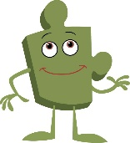 | Changing Me
Key: PSHE Learning Intentions / Social and Emotional Skills Learning Intentions
 | Year 7 Summer 2 | Year 8 Summer 2 | Year 9 Summer 2 | Year 10 Summer 2 | Year 11
 | How do I feel about becoming an adult? | What factors can make an intimate relationship happy and healthy? | How can change affect mental health? | Can all change be positive in some way?
Changing Me – Jigsaw Summer 2 | Puberty  - I can understand the physical and emotional changes that happen during puberty  - I recognise that puberty happens at different times for different people  - I can identify different strategies for managing change and maintaining good hygiene  - I feel confident asking questions and seeking support about puberty-related concerns  Having a baby  - I know how a baby is conceived naturally  - I know that there are other ways a baby can be conceived, e.g. IVF I understand how a baby develops inside the uterus and is born  - I can express the different feelings and choices that people may have and make about conception, pregnancy and having a baby  - I can appreciate that a baby comes with responsibilities  Family relationships and choices  - I know there are different types of committed stable relationships and that some people may choose to have children or not  - I can make links between positive, healthy family relationships and effective parenting  - I can identify some of the roles and responsibilities of being a parent  - I can understand that stable intimate relationships can be linked to happiness  Image and self-esteem  - I know that the media can have a positive or negative impact on a person's self-esteem or body image  - I know where to go for help if I am worried about my body image or self-esteem  - I understand how self-image is linked to self- esteem  - I can apply strategies to build my self-esteem | Different types of relationship  - I can highlight different types of close, intimate relationships that people can have​  - I can explain what happens physically and emotionally when individuals experience physical attraction  - I know that intimate relationships do not have to involve sex  - I know some of the positive behaviours seen in healthier, intimate relationships | Change and our emotions  - I know that change can trigger a range of emotional responses  - I know that some changes can be more difficult to manage than others  - I know that going through change can develop resilience  - I can suggest ways I can manage change in my life | Changing society and me.  - I can identify some of the changes in society that will affect me  - I can discuss the emotional impact societal change can have on young people  - I can assess the role of media, including social media, on social change  - I understand that change is inevitable and have strategies to manage feelings about this | Curriculum time in Summer 2 for Y11 students is allocated to revision, exam preparation and examinations.  The PSHE curriculum in Summer 2  consists of The Votes for Schools programme, assemblies and other events, and dedicated, specific lessons in relation to FBV. These ensure students:  - have an age-appropriate understanding of FBV that builds on previous learning  - Student understand relevant historical, social and political contexts that relate to each value.  - Students understand how FBV apply in live beyond school.
Personal safety on the roads, railways and around water
- I know how to identify some potential risks to my personal safety in a number of common situations
- I can recognise how my increasing independence means I am responsible for considering my own safety
- I understand some risks associated with life experiences when no adults are present
- I understand that as I become more independent, I become more responsible for my own well-being and safety

Changing Me – Jigsaw Summer 2 |  |  | Changing and growing  - I know different ways someone might choose to express themselves (self-expression)​  - I understand some of influences that can affect a person's body image and how they might choose to express themselves​  - I understand the choices I have relating to my body image and self-expression​
Changing Me – Jigsaw Summer 2 |  | What’s in a relationship?  - I understand the positive aspects of having a girlfriend or boyfriend  - I can describe some of the behaviours you would expect to find in a healthy romantic relationship  - I can identify what you would seek in a boyfriend/girlfriend relationship  - I can compare and contrast the key features of healthy and unhealthy romantic relationships  Looks and smiles.  - I can understand the range of feelings associated with attraction  - I know where to get information to safely explore feelings about sexuality  - I recognise that attraction towards others takes many forms and can change over time  Pornography and understanding relationships  - I know that pornographic images do not reflect reality  - I know how pornography can impact on expectations and self-image  - I recognise the role of pornography in society  - I understand the negative influence pornography can have on relationships  Alcohol  - I can list some risks associated with drinking too much alcohol, including unprotected sex, non-consensual sex  - I know what the law says in relation to sex and alcohol  - I can discuss the steps someone could take if they had engaged in risky sexual behaviour as a result of drinking too much alcohol  - I can describe the behaviour changes that can occur when people drink alcohol  Assessment  - I can summarise behaviours and attitudes that could make a relationship healthy or unhealthy  - I can explain some risks associated with pornography or alcohol use in relation to relationships  - I can express my own opinions on relationship issues
Identifying risk and managing personal safety
- I know how alcohol can affect personal decision making.
- I can plan for situations where I need to consider my own safety
- I understand some risks associated with life experiences when no adults are present
- I understand that as I become more independent, I become more responsible for my own well-being and safety

Stereotypes and exploring relationships
- I can discuss gender and stereotypes in relation to a range of romantic relationships
- I can identify and understand the legislation relating to a range of relationships
- I understand the range of emotions individuals can experience in relation to romantic relationships

Virginity testing and hymenoplasty
- I can define virginity testing and hymenoplasty and explain why these practices take place in certain cultures and the myths/facts associated​
- I can explain why these practices are classified as human rights violations​
- I know where to access support if needed​
- I can identify that different standards exist for girls/women vs. boys/men regarding virginity and challenge misogynistic attitudes​
- I can appreciate the complexity of navigating cultural identity whilst upholding human rights

Assessment
- I can reflect on physical changes experienced so far​
- I understand the relationship between physical change, self-esteem and emotional change​
- I understand the impact of family change and how it can affect future relationships​
- I can discuss the difficulties associated with the physical and emotional changes young people can experience​
- I can describe some of the strategies that can be helpful in managing change and identify sources of support​

Changing Me – Jigsaw Summer 2 |  |  | Masculinity and online influence  - I can identify different messages about masculinity from media and online sources​  - I can recognise persuasive techniques used by online influencers​  - I can think critically about content I might encounter online  Misogyny, incel culture and building healthy relationships  - I can define misogyny and recognise it in online spaces​  - I understand what incel culture is and why it's harmful​  - I can identify warning signs of unhealthy online content​  I can develop a range of strategies for building healthy relationships and handling rejection ​  Mental health and addiction  - I know that my mental health can be affected by different situations and experiences  - I know about some common mental health issues  - I can challenge stigma about mental health issues  - I know where to access support if I am worried about my mental health  - I appreciate that the people in my life may have a range of different views and opinions  Assessment  - I can summarise how different types of change can affect mental health and know some strategies to stay resilient  - I can change manage change positively and know where to get help if I need it
Changing Me – Jigsaw Summer 2 | My body, my rights - FGM  - To know that no one can make changes to my body without my permission and that FGM is illegal in the UK  - To be able to identify who to ask for help and advice about myself or a friend, even if it something that is hard to talk about
Changing Me – Jigsaw Summer 2 | Assessment  - I can summarise the potential impact of changes in puberty on how I feel and suggest ways to cope with the changes  - I can identify factors and activities that will impact on my mood both positively and negatively

 | Northampton International Academy  Tutor Time (Votes for Schools) |  | 
 |  | Votes for Schools is a voting platform for young people that strives to make a difference in your school, local community, and the wider world, and to highlight the importance of being informed, curious, and heard. Two tutor sessions every week are dedicated to exploring a topic from the nine key themes below in an in-depth and age-appropriate way. Vote topics are based on current events and often challenging issues. After each session, students vote, making their voices on issues heard. The online voting platform shows how students have voted compared to the national picture as well as broken down by age and gender giving you a real insight into what they think and feel about a range of diverse issues.
Health and Wellbeing | Equalities and Identity |  | Environment and Climate Change |  | Global Issues and Politics |  | Science and Technology
Mental wellbeing  Mental health disorders, stress, work-life balance, sports, exercise, mindfulness,  happiness, emotional health, self-esteem, body image, eating disorders, self harm, abuse, suicide  Health & medicine  NHS, obesity, diet, vaccines, antibiotics, HIV/aids, sanitation, periods, medicine,  cancer, organ donation, sexual health, smoking, drugs, gambling, addiction  Healthy relationships  Keeping yourself safe, sexualisation, consent, sexual harassment, positive  relationships, malnutrition, child marriage, domestic violence, online safety,  pornography, exploitation, FGM, sexual health | Protected characteristics  Gender, race, age, sex, sexuality, religion, disability/learning difficulties, marriage  and civil partnership, pregnancy & maternity  Attitudes & isms  Sexism, gender equality, feminism, racism, islamophobia, anti-Semitism,  prejudice, stereotyping, discrimination, stigma, bullying, banter, toxic  masculinity, “lad” culture, harassment, hate crime  FBV links: societal issues  Human rights, integration, immigration/emigration, passports, citizenship,  tolerance, power, vulnerability |  | Global warming  Climate change, pollution, natural resources, energy, recycling, factory farming,  sustainability, travel, air quality, transportation  Weather & climate  Natural disasters (cause & prevention), extreme weather events, migration, environmental refugees  Nature & ecosystems  Wildlife, animal welfare, conservation, extinction, plastic, waste disposal, consumerism, housing, urbanisation, development, national parks, water, oceans, forests, parks, space |  | UK issues  Brexit, free school meals, Coronavirus response, cronyism, inequalities, UK political parties, general elections, local elections, censuses, surveys, polls  Global issues  War & peace, refugees, poverty, population, food & water scarcity, corruption, conflict, access to education, health epidemics, transparency, interdependence, populism, inequality, globalisation, military, nuclear weapons, biosecurity, famine, power, humanitarian crises, trafficking  FBV links: politicians & systems  Political leaders, movements, democracy, democratisation, dictators, types of political system, national identity, freedom of speech, international security |  | Discoveries & research  New scientific research, GM crops, lab-grown meat, stem cell research, controversial scientific innovations, infrastructure, ethics  Personal devices & tech  Personal devices (e.g. mobile phones & tablets), life online, social media, data security, surveillance, algorithms, Virtual Reality, privacy, cybersecurity  The future of tech  New technological advances (e.g. drones & robots), artificial intelligence, the changing of the news, automation of cars and jobs, space exploration & travel
Community and Charity |  | Crime, justice & extremism |  | Jobs, economy & education |  | Culture, media & the arts
Citizenship  Housing, family life, inequalities between parts of the UK, lifestyles, foreign aid, international solidarity.  FBV links: Integration, immigration, multiculturalism, services, society, shared values, respecting differences.  Charity & altruism  Local charities, fundraising, food banks, supporting the elderly, homelessness, neighbours & communities across borders (e.g. the EU)  FBV links: Integration, immigration, multiculturalism, services, society, shared values, respecting differences.  Community action  Petitioning, campaigning, land reform, loneliness, free school meals, the NHS, volunteering, youth groups |  | Societal issues  Access to health & social care, anti-social behaviour, money laundering, minority issues, gangs, knives & weapons, violence, grooming, child trafficking, genocide, modern slavery  Authorities & the law  Crime, privacy, surveillance, police, criminal justice system, prisons system, role of Parliament and House of Lords in making laws, secret service, death penalty  FBV links: attitudes & extremism  Political divisions, polarisation, freedom of speech, no-platforming, conspiracy theories, radicalisation, extremism, terrorism, crimes against humanity |  | Careers & employment  Teamwork, entrepreneurship, business, work-life balance, transnational corporations, international trade, fair trade, job markets, future of jobs  Finances & economy  Financial literacy, budgeting, investment, tax, credit cards, borrowing/debt, role of banks, Government spending, financial crises  Continuing education  Ambition, goals, school, learning, exams, education system, tests, apprenticeships, qualifications, university, unemployment |  | Culture & heritage  Language, sport, food & drink, museums, libraries, galleries, parks, tourism, philosophy, remembering people who shaped the UK  Media & entertainment  News & TV consumption, fake news, analysing the news, advertising, brands, celebrities, cancel culture, film, music, books, art, podcasts, social media  FBV links: British “institutions”  British customs & traditions, “Britishness”, the Royal Family, UK political parties, Church & State

Northampton International Academy
Appendix 1 – SMSC
Spiritual Development |  | Moral Development | Social Development |  | Cultural
Explore beliefs and experience; respect faiths, feelings and values; enjoy learning about oneself, others and the surrounding world; use imagination and creativity; reflect.  FBV links: liberty, respect and tolerance. |  | Recognise right and wrong; respect the law; understand consequences; investigate moral and ethical issues; offer reasoned views.  FBV links: rule of law. | Use a range of social skills; participate in the local community; appreciate diverse viewpoints; participate, volunteer and cooperate; resolve conflict. FBV links: democracy, the rule of law, liberty, respect and tolerance. |  | Appreciate cultural influences; appreciate the role of Britain's parliamentary system; participate in culture opportunities; understand, accept, respect and celebrate diversity.  FBV links: liberty, respect and tolerance.
Personal values and beliefs  - Voters have the opportunity to be reflective about their own beliefs (religious or otherwise)  - Voters use personal experiences to reflect on their lives  - Voters demonstrate defence in their aims, values, principles & beliefs  - Voters can be holistic in their approach to discussing topics  - Schools support voters with their religious beliefs in a personalised way  - Schools facilitate discussions to support reflection  Experiencing Wonder and Fascination  - Voters learn about themselves, others & the world around them  - Voters develop an appreciation of the intangible (e.g. love, ambiguity)  - Schools allow voters to ask questions: why? How? Who? Where? What?  Understanding human feelings and emotions  - Voters show interest and respect for others’ faiths, feelings and beliefs  - Voters develop empathy, compassion & concern with others  - Voters challenge the barriers & constraints to the human spirit (e.g. injustice, greed, poverty, discrimination)  - Voters develop a respect for insight as well as for knowledge & reason  - Voters develop an understanding of feelings & emotions and the impact of them  - Schools allow opportunities for voters to understand human feelings and how these affect us  - Schools develop a culture where voters can flourish, grow and respect others  - Schools accommodate difference and respect the integrity of individuals  - Voters are encouraged to think and use their imaginations & sense of creativity  - Staff value voters’ questions and give them space for their own thoughts, ideas & concerns |  | Developing and Expressing Personal Views  - Voters are interested in investigating and adding their own views on moral & ethical issues  - Voters are able to express their views on ethical & personal issues  - Voters are committed to their own values even if others think they are wrong  - Voters enjoy discovering their own and others’ views on different topics  - Voters can adapt their values in light of experiences  - Schools create platforms for voters which are safe for them to explore their views and practice moral decision-making  Investigating Moral and Ethical issues  - Voters are interested in investigating others’ viewpoints and are able to understand others may hold different views on these issues  - Schools use learning to prevent discrimination  - Schools give opportunities to explore rights & responsibilities, truth, justice, equality and right & wrong  - Voters respect there are different cultures in society and within their school  Moral Codes and Models of Moral Virtue  - Schools model fairness, integrity, respect for people, voters’ welfare, minority groups and resolution of conflict  Recognising Right and Wrong and Apply  - Voters know right from wrong and apply this, respecting civil & criminal law  - Voters know right from wrong based on their own moral code & other cultures  - Voters make reasoned & responsible judgements on moral dilemmas  Understanding Consequences of Actions  - Voters understand the consequences both positive & negative of their actions (cause and effect)  - Schools encourage voters to take responsibility (e.g. taking care of their environment, respect) | Developing Qualities and Social Skills  - Voters use a range of social skills in different contexts including working alongside those from differing religions & socio-economic backgrounds  - Voters are given the chance to adjust their behaviour to a range of social contexts demonstrating sensitivity  - Voters reflect on their own contribution to school & their communities  - Voters show respect for people, living things, property & their environment  - Schools encourage voters to recognise and respect social differences & similarities  - Schools help voters develop their personal qualities such as thoughtfulness, respect for difference, moral principles  - Schools provide a platform for understanding and debating social issues  - Schools provide opportunities for voters to engage in a democratic process and participate in community life  - Schools provide appropriate links to the wider world & the community  Participating and Resolving Conflict  - Voters co-operate well and are able to resolve their conflicts  - Voters work well together as members of groups or teams; they relate well to each other  - Voters are given the platform to challenge appropriately the views of a group or the wider community  - Voters resolve conflicts and counter forces which militate against inclusion & unity  - Schools provide voters with the chance to exercise leadership & responsibility  Understanding how Communities Function  - Voters engage with and accept the values of democracy, the rule of law, individual liberty, and mutual respect & tolerance of those with differing beliefs & faiths  - Voters develop skills & attitudes that will allow them to participate fully in democracy and contribute to society  - Voters appreciate the rights & responsibilities of individuals within the wider setting  - Voters understand how society functions and is organised  - Voters understand the notion of interdependence in a complex society  - Schools identify key values & principles on which school & community life is based |  | Understanding and Respecting Diversity  - Voters explore and show understanding and respect for different faiths & cultural diversity  - Voters are given the platform to demonstrate their tolerance & positive attitude to local, national & international communities  - Voters develop an ability to appreciate different cultures and demonstrate dignity & respect to others’ views; they challenge discriminatory behaviour  - Voters develop an openness to new ideas and are willing to change their views in light of new experiences  - Voters are given the opportunity to engage positively in cultural debates & opportunities  - Voters develop personal enrichment through encounter with cultural media & traditions from a range of cultures  - Schools provide opportunities for voters to engage in cultural events and to reflect on their significance  - Schools develop partnerships with outside agencies to extend voters’ cultural awareness  Preparing for life in Modern Britain  - Voters know about Britain’s democratic parliamentary system and how it shapes our history & values  Understanding and Resecting Diversity  - Voters understand how beneficial it is to appreciate a range of different cultures and that this is preparation for them as part of a modern Britain  - Voters develop an ability to challenge their own cultural assumptions & values  - Voters can identify the cultural influences that have helped shape their own heritage & behaviours  - Schools audit the quality & nature of opportunities for voters to extend their cultural development  Understanding and Appreciating Influences  - Voters are given opportunities to understand how a wide range of cultural influences have shaped their own heritage

Northampton International Academy
Appendix 2 – Fundamental British Values and Prevent

Prevent Strategy | Promoting Fundamental British Values
Schools provide a safe place to discuss and debate topical & controversial issues affecting young people  Voters can influence and participate in decision-making on issues affecting them in their society  Voters can participate in decision-making within their own school environment  Voters can express their views and appreciate the impact their views can have on others  Voters can discuss terrorism and the wider use of violence in a considered & informed way  Schools can facilitate understanding of wider societal issues and how we can exercise democracy to influence change  Voters should be given the platform to challenge Islamophobia, Antisemitism & other prejudices  Voters should use safe-to-learn anti-bullying strategies to minimise hate- & prejudice-based bullying  Voters should know how to challenge extremist narratives and promote universal rights  Voters should develop questioning skills & techniques to open up debate in a safe way  Voters should feel confident to discuss honestly a plurality of views  Schools should allow voters to debate fundamental moral & human rights principles  Schools should promote open & respectful dialogue  Model participatory and representative democracy by engaging and examining views expressed  Encourage voters as citizens to support the vulnerable and to use democratic & lawful vehicles for protest  Help voters to develop the skills needed to evaluate effectively and discuss potentially controversial issues  Use spaces for voters to discuss openly issues that concern them, including exploring their own identities & how these relate to the diversity of the society in which they live  Give voters a safe place to respond to current events that will challenge their beliefs | Voters should gain an understanding of how citizens can influence decision-making through the democratic process  Voters should have an appreciation that living under the rule of law protects individual citizens and is essential for their wellbeing & safety  Voters should understand that there is a separation of power between the executive & the judiciary (e.g. police answerable to Parliament)  Voters should understand that the freedom to choose and hold other faiths & beliefs is protected in law  Voters should accept that other people having different faiths or beliefs to oneself (or having none) should be accepted and tolerated, not discriminated against  Voters should have an understanding of the importance of identifying and combatting discrimination  Understand the strengths, weaknesses, advantages & disadvantages of democracy, and how democracy & the law works in Britain, in contrast to other forms of government in other countries  Ensure that all voters within the school have a voice that is listened to, and demonstrate how democracy works by actively promoting democratic processes such as a school council whose members are voted for by voters  Voters should experience elections that provide them with the opportunity to learn how to argue and defend points of view  Schools should use teaching resources from a wide variety of sources to help voters understand a range of faiths  Schools should consider the role of extra-curricular activity, including any run directly by voters, in promoting fundamental British Values

Northampton International Academy
Tutor Time (Votes for Schools) – British Values
 |  |  | Votes for Schools is a voting platform for young people that strives to make a difference in your school, local community, and the wider world, and to highlight the importance of being informed, curious, and heard. Below is a list of indicative vote topics.
enable students to develop their self-knowledge, self-esteem and self-confidence; |  | Votes for Schools topic question example – ‘Does the internet affect the way we view sex and relationships?’  Votes for Schools topic question example – ‘Are we getting better at recognising burnout?’  Votes for Schools topic question example – Does learning about your emotions help you feel better?
enable students to distinguish right from wrong and to respect the civil and criminal law of England; |  | Votes for Schools topic question example - ‘Should everyone be able to vote at 16?’  Votes for Schools topic question example – ‘Are young people comfortable calling out misogynistic behaviour?’  Votes for Schools topic question example – ‘Is it important for future generations to learn about VE Day?
encourage students to accept responsibility for their behaviour, show initiative, and  to understand how they can contribute positively to the lives of those living and  working in the locality of the school and to society more widely; |  | Votes for Schools topic question example - ‘Should we be worried about vaping?’  Votes for Schools topic question example - ‘Do fandoms encourage bullying?’  Votes for Schools topic question example – ‘Do we underestimate the impact of food banks?’  Votes for Schools topic question example – Do we view the term "refugee" positively?
enable students to acquire a broad general knowledge of and respect for public  institutions and services in England; |  | Votes for Schools topic question example - ‘Should everyone be able to vote at 16?’  Votes for Schools question example – ‘Should violence against shop workers be made its own law across the UK?’  Votes for Schools question example – ‘Does the Coronation reflect the UK today?’
further tolerance and harmony between different cultural traditions by enabling  students to acquire an appreciation of and respect for their own and other cultures; |  | Votes for Schools topic question example - ‘Was awarding the World Cup to Qatar a mistake?’  Votes for Schools question example ‘Should accent be a protected characteristic?’  Votes for Schools question example – ‘Do we understand the difference between appropriation and appreciation?’
encourage respect for other people |  | Votes for Schools topic question example - ‘Do fandoms encourage bullying?’  Votes for Schools topic question example - ‘Is progress around BSL happening quickly enough?’  Votes for Schools topic question example – ‘Do we underestimate the impact of food banks?’  Votes for Schools topic question example – ‘Should non-LGBTQ+ people tell LGBTQ+ stories?’  Votes for Schools topic question example – Does LGBT+ representation help everyone feel safer in school?
encourage respect for democracy and support for participation in the democratic  processes, including respect for the basis on which the law is made and applied in  England. |  | Votes for Schools topic question example - ‘Was awarding the World Cup to Qatar a mistake?’  Votes for Schools topic question example - ‘Should everyone be able to vote at 16?’  Votes for Schools topic question example - Should ending child poverty be a top priority for the UK Government?  Votes for Schools topic question example - Would you use a local youth space? | Will there still be youth spaces in the future?

 |  | Northampton International Academy  Personal Development Curriculum Overview  Fundamental British Values (Secondary phases) |  |  |  |  | 
Fundamental British Values
 |  |  | Year 7 | Year 8 | Year 9 | Year 10 |  | Year 11 | Post 16 | Whole School
FBV1 | Right from wrong and rule of Law  Enable students to distinguish right from wrong and to respect the civil and criminal law of England.  (An appreciation that living under the rule of law protects individual citizens and is essential for their wellbeing and safety) |  | - Anti-Bullying Assembly  - Healthy Me PSHE unit  - Three external FBV assemblies  - Safer internet day KS3 drop down | - Anti-Bullying Assembly  - Healthy Me PSHE unit  - Safer internet day KS3 drop down | - Anti-Bullying Assembly  - Healthy Me PSHE unit  - Safer internet day KS3 drop down | - Anti-Bullying Assembly  - Being Me in my World PSHE unit  - Healthy Me PSHE unit  - Sexual Harassment assembly  - Physical assault assembly |  | - Anti-Bullying Assembly (focused on further education and workplace bullying)  - Being Me in my World PSHE unit  - Healthy Me PSHE unit  - Sexual Harassment assembly  - Physical assault assembly | - Anti-Bullying Assembly (focused on further education and workplace bullying)  - Sexual Harassment assembly  - Physical assault assembly | - FBV assemblies (introduction to PSHE, remembrance, Disability History Month)  - Votes for Schools debate topics  - Sex and relationships drop down day
FBV2 | Tolerance of those with different faiths and beliefs  Further tolerance and harmony between different cultural traditions by enabling students to acquire an appreciation of and respect for their own and other cultures.  (An understanding that the freedom to choose and hold other faiths and beliefs is protected in law.) |  | - Being Me in my World PSHE unit  - Celebrating Difference PSHE unit  - Three external FBV assemblies  - Diversity, Equality and Discrimination Assembly | - Being Me in my World PSHE unit  - Celebrating Difference PSHE unit  - Diversity, Equality and Discrimination Assembly | - Being Me in my World PSHE unit  - Celebrating Difference PSHE unit  - Diversity, Equality and Discrimination Assembly | - Celebrating Difference PSHE unit  - Diversity, Equality and Discrimination Assembly |  | - Relationships PSHE unit  - Diversity, Equality and Discrimination Assembly | - Diversity, Equality and Discrimination Assembly  - Diversity, Equality and Discrimination Assembly | - FBV assemblies (introduction to PSHE, remembrance, Disability History Month)  - Diversity, Equality and Discrimination Assembly  - RE curriculum  - Votes for Schools debate topics
FBV3 | Individual Liberty and Mutual Respect  Encourage respect for other people.  (An acceptance that other people having different faiths or beliefs to oneself (or having none) should be accepted and tolerated and should not be the cause of prejudicial or discriminatory behaviour.) |  | - Being Me in my World PSHE unit  - Celebrating Difference PSHE unit  - Three external FBV assemblies  - Safer internet day KS3 drop down | - Being Me in my World PSHE unit  - Celebrating Difference PSHE unit  - Safer internet day KS3 drop down | - Being Me in my World PSHE unit  - Celebrating Difference PSHE unit  - Safer internet day KS3 drop down | - Celebrating Difference PSHE unit |  | - Relationships PSHE unit  - Anti-Bullying Assembly (with a focus on higher education and workplace bullying, references to rights and responsibilities) | - Diversity, Equality and Discrimination Assembly  - Anti-Bullying Assembly (with a focus on higher education and workplace bullying, references to rights and responsibilities) | - FBV assemblies (introduction to PSHE, remembrance, Disability History Month)  - Votes for Schools debate topics  - Sex and relationships drop down day
FBV4 | Democracy  Encourage respect for democracy and support for participation in the democratic processes, including respect for the basis on which the law is made and applied in England. (An understanding of how citizens can influence decision-making through the democratic process.) |  | - Three external FBV assemblies | - Weekly Votes for Schools tutor sessions | - Weekly Votes for Schools tutor sessions | - Weekly Votes for Schools tutor sessions |  | - Weekly Votes for Schools tutor sessions | - Weekly Votes for Schools tutor sessions | - FBV assemblies (introduction to PSHE, remembrance, Disability History Month)  - Votes for Schools  - Pupil Parliament  - Votes for Schools debate topics

The Equalities Act and the protected characteristics at NIA

It is important that all children gain an understanding of the world they are growing up in, and learn how to live alongside, and show respect for, a diverse range of people. Our PSHE and wider curriculum we teach pupils to gain an age appropriate understanding of the Equalities Act in relation to the protected characteristics and what this means in pupils’ lives. This links closely to pupils’ understanding of the FBV. Below are listed some key examples of where were cover these things in our PSHE, RSE, RE and other curriculum. These important ideas are developed and reinforced throughout the school curriculum and school life.
 |  | Primary | KS3 | KS4 | KS5
PC1 | Age | - Pupil leadership roles encourage respect for people who are older than ourselves.  - Science – Animals incl humans (Life process)  - Invite local care home to nativity performance.  - PSHE – Changing me Unit (Y2,)  - Celebrate birthdays | - Protected Characteristics (Diversity, Equality and Discrimination) Assembly  - Votes for Schools debate topics | - Protected Characteristics (Diversity, Equality and Discrimination) Assembly  - Votes for Schools debate topics | - Protected Characteristics (Diversity, Equality and Discrimination) Assembly  - Votes for Schools debate topics
PC2 | Disability | - Guide dogs assembly – FS to schedule  - Cube – invite to Christmas nativity performance | - Disability History Month awareness assemblies and activities  - Protected Characteristics (Diversity, Equality and Discrimination) Assembly  - Votes for Schools debate topics  - Disability history month assembly | - Disability History Month awareness assemblies and activities  - Protected Characteristics (Diversity, Equality and Discrimination) Assembly  - Votes for Schools debate topics  - Disability history month assembly | - Disability History Month awareness assemblies and activities  - Protected Characteristics (Diversity, Equality and Discrimination) Assembly  - Votes for Schools debate topics  - Disability history month assembly
PC3 | Gender Reassignment  (Gender identity) | - Tackling stereotypes  - Non-gender uniform code  - Celebrating Difference units through Jigsaw | - Celebrating Differences PSHE unit  - Pride Month Assembly  - LGBTQ+ History Month Assemblies  - Protected Characteristics (Diversity, Equality and Discrimination) Assembly  - Votes for Schools debate topics | - Celebrating Differences PSHE unit  - Pride Month Assembly  - LGBTQ+ History Month Assemblies  - Protected Characteristics (Diversity, Equality and Discrimination) Assembly  - Votes for Schools debate topics | - Pride Month Assembly  - LGBTQ+ History Month Assemblies  - Protected Characteristics (Diversity, Equality and Discrimination) Assembly  - Votes for Schools debate topics
PC4 | Marriage and Civil Partnership | - Social stories/picture books – add to class libraries, T to read at EOD as class text.  - PSHE- - Being Me in My World/Relationships/Celebrating differences unit | - Celebrating Differences PSHE unit  - Pride Month Assembly  - LGBTQ+ History Month Assemblies  - Protected Characteristics (Diversity, Equality and Discrimination) Assembly  - Votes for Schools debate topics | - Celebrating Differences PSHE unit  - Pride Month Assembly  - LGBTQ+ History Month Assemblies  - Protected Characteristics (Diversity, Equality and Discrimination) Assembly  - Votes for Schools debate topics | - Pride Month Assembly  - LGBTQ+ History Month Assemblies  - Protected Characteristics (Diversity, Equality and Discrimination) Assembly  - Votes for Schools debate topics
PC5 | Pregnancy and Maternity | - Mothers’ Day – KS1  - Mums’ Breakfast  - IVF – Changing me unit | - Healthy Me PSHE unit  - RSE drop down day 6th Oct  - Protected Characteristics (Diversity, Equality and Discrimination) Assembly  - Votes for Schools debate topics | - Healthy Me PSHE unit  - RSE drop down day 6th Oct  - Protected Characteristics (Diversity, Equality and Discrimination) Assembly  - Votes for Schools debate topics | - RSE drop down day 6th Oct  - Protected Characteristics (Diversity, Equality and Discrimination) Assembly  - Votes for Schools debate topics
PC6 | Race/ethnic/national origin | - Celebrating Differences – cultural day.  - European Languages Day  - International food event  - Queen`s Jubilee  - Royal Weddings | - Black History Month Assembly  - Black History Lesson guest speaker  - Manisha Tailor MBE guest speaker  - Protected Characteristics (Diversity, Equality and Discrimination) Assembly  - Votes for Schools debate topics | - Black History Month Assembly  - Black History Lesson guest speaker  - Manisha Tailor MBE guest speaker  - Protected Characteristics (Diversity, Equality and Discrimination) Assembly  - Votes for Schools debate topics | - Black History Month Assembly  - Protected Characteristics (Diversity, Equality and Discrimination) Assembly  - Votes for Schools debate topics
PC7 | Religion or Belief | - Eid parties  - Trips to religious buildings  - Christmas parties  - RE curriculum – SF to update  - Easter egg decorating/hunt  - Religious visitors  - Advent Fair  - Diwali  - Chinese New Year | - Manisha Tailor MBE guest speaker  - Protected Characteristics (Diversity, Equality and Discrimination) Assembly  - Votes for Schools debate topics  - Black influence assembly  - Chinese New Year assembly and events | - Manisha Tailor MBE guest speaker  - Protected Characteristics (Diversity, Equality and Discrimination) Assembly  - Votes for Schools debate topics  - Black influence assembly  - Chinese New Year assembly and events | - Protected Characteristics (Diversity, Equality and Discrimination) Assembly  - Votes for Schools debate topics  - Black influence assembly  - Chinese New Year assembly and events
PC8 | Sex | - Changing Me units through Jigsaw | - Enrichment curriculum events  - Protected Characteristics (Diversity, Equality and Discrimination) Assembly  - Changing Me PSHE unit  - Relationships PSHE unit  - Votes for Schools debate topics  - LGBTQ+ History Month Assemblies | - Enrichment curriculum events  - Anti-Bullying Assembly (references to workplace bullying and gender stereotypes/discrimination  - Protected Characteristics (Diversity, Equality and Discrimination) Assembly  - Changing Me PSHE unit  - Relationships PSHE unit  - Votes for Schools debate topics  - LGBTQ+ History Month Assemblies | - Enrichment curriculum events  - Anti-Bullying Assembly (references to workplace bullying and gender stereotypes/discrimination  - Protected Characteristics (Diversity, Equality and Discrimination) Assembly  - Votes for Schools debate topics  - LGBTQ+ History Month Assemblies
PC9 | Sexual Orientation | - Social stories/picture books – add to class libraries, T to read at EOD as class text. | - Enrichment curriculum events  - Pride Month Assembly  - LGBTQ+ History Month Assembly  - Protected Characteristics (Diversity, Equality and Discrimination) Assembly  - Relationships PSHE unit  - Votes for Schools debate topics  - LGBTQ+ History Month Assemblies | - Enrichment curriculum events  - Pride Month Assembly  - LGBTQ+ History Month Assembly  - Protected Characteristics (Diversity, Equality and Discrimination) Assembly  - Relationships PSHE unit  - Changing Me PSHE unit  - Votes for Schools debate topics  - LGBTQ+ History Month Assemblies | - Enrichment curriculum events  - Pride Month Assembly  - LGBTQ+ History Month Assembly  - Protected Characteristics (Diversity, Equality and Discrimination) Assembly  - Votes for Schools debate topics  - LGBTQ+ History Month Assemblies

